Enrolment
Policy
Of Firhouse Educate Together National School

Address: Ballycullen Drive, Firhouse, Dublin.24.
Telephone: 01 406 1010
Email: firhouseetns@gmail.com
Roll Number: 20411J

Introduction 1
School Details 1
General Information 1
Eligibility Criteria 1
Categories used to prioritise applications for enrolment 3
Pupils with Special Educational Needs 4
Code of Behaviour 4
Refusal to Enrol 5
Appeal Procedure 5
Appendix 1: Admissions Procedures 7
Appendix 2: Educate Together Charter: 7

Introduction

The enrolment policy of Firhouse Educate Together National School (“Firhouse ETNS”) has been devised in accordance with the provisions of the Education Act 1998, the Education (Welfare) Act 2000, Equal Status legislation, directives of the school’s Patron and following consultation with the school community.

The core value that determines enrolment of pupils in Firhouse ETNS in accordance with this enrolment policy, is equality of access and participation in the school for all children in our society whatever their social, religious, cultural or racial background and/or whether or not they have a disability or special educational needs.

In this policy, reference to parents is to be taken as including reference to guardians, reference to child is to be taken to include a child who has been adopted and reference to siblings is to be taken as including reference to step siblings.

School Details
Firhouse ETNS operates with the patronage of Educate Together. Parents are advised to familiarise themselves with the Educate Together ethos prior to applying to enrol their child in the school. Educate Together’s Charter is attached in Appendix 2.

Firhouse ETNS is a co-educational National School and is equality based. It operates in accordance with relevant legislation, the Rules for National Schools and statutory regulations/directions/circulars issued from time to time by the Department of Education & Skills (“DES”) and its Patron. It is dependent on grants, teaching and other resources provided by the DES, the National Council for Special Education (“NCSE”) and the Health Service Executive (“HSE”).

Firhouse ETNS is a developing school and currently enrols pupils into Junior Infants and for September 2017 into Senior Infants, First Class, Second Class and Third Class. The school will ultimately cater for pupils from Junior Infants to Sixth Class.

Firhouse ETNS follows the Curriculum prescribed by the DES and the Patron in accordance with the Act.

General Information
The school day starts at 08.25 for all classes and finishes at 13.05 for Junior & Senior Infants and at 14.05 for all other classes.

In determining the level of admissions, the Board of Management (“BoM”) shall take account of DES regulations/circulars in relation to staffing, class size and pupil teacher ratios. The BoM shall also have regard to issues such as physical space, multi- grade classes and the presence of children with special educational and/or behavioural needs.

Eligibility Criteria
Under the Rules for National Schools, a child may not be allowed to attend or be enrolled in a national school before the fourth anniversary of his/her birth.

In Firhouse ETNS in order to be enrolled, an applicant must be four years of age on or before May 1st preceding the September in respect of which the application for enrolment into junior infants relates to.

Enrolment Application Procedure
It should be noted that the submission of an application form(s) does not confer a right to enrolment.
The official application form must be used. This will be available on www.firhouseetns.ie from 3rd May 2017 for September 2018.
A separate form must be used in respect of each child’s application for enrolment.
The strict deadline for receipt of fully completed enrolment applications for 2018 is 17.00 on Monday 23rd October 2017 (‘The closing date’).
Incomplete applications will not be considered. An application will be deemed incomplete unless:

      - The official enrolment application form is fully completed online.

      - A copy of the applicant’s birth certificate is submitted to the school following the online application and before the closing date.
      - Proof of address in the form of a utility bill in the name of one of the parents, which must be dated no later than three months prior to the date of application, is submitted to the school following the online application and before the closing date.
Failure to submit the birth certificate will mean that the application is considered incomplete and will not be considered.
Failure to submit proof of address, means that the applicant will not receive any priority in respect of priority category 2. This also applies where proof of address is submitted after the closing date.
Submitting inaccurate information on an application form or in accompanying documentation will render the application void ab-initio and where a place has been offered will result in the offer of the place being withdrawn and reallocated and/or in the case of placement on a waiting list, removal from the waiting list and the offer of a place will not be made even where a place for that number on the waiting list becomes available.
Written notification of the decision regarding the application will be issued to parents within 21 days of the Closing Date.
Parents of applicants who have been offered a place must inform the school in writing, by completing and returning to the school an enrolment acceptance form within 14 working days. Failure do so will result in the place being forfeited and reallocated.

Offers of places may not be deferred.

Pupils will, as a rule, only be admitted into Junior Infants during the month of September. Pupils may be admitted to Junior Infants during the school year provided they are transferring from another school and were enrolled in that other school during the month of September.

If the application for enrolment is successful and the place has been accepted as outlined above, the pupil shall be enrolled as per his/her name on his/her official birth certificate.

Applicants in respect of whom a fully completed application form has been submitted who are not successful in securing a place, will be placed on a waiting list in the order of priority of the categories listed below.

The waiting list will expire on 30th September of the year of intake.

Categories used to prioritise applications for enrolment
The categories below, which are listed in order of priority, are used to determine the priority order given to applications when the number of applications received outnumbers the number of places available.

The categories below are also used to determine the new priority order given to all applicants pre-enrolled on our current lists for future years. All of these families will be informed in writing immediately of the new priority category their application will come under.

In the event of the number of applicants in Priority Categories 1, 2 & 3 outnumbering the remaining available places, places will be offered to complete applications beginning with the oldest eligible applicant in that category and proceeding in descending order of age from the oldest to the youngest until all remaining available places have been filled. In the event of the number of applicants in Priority Category 4 outnumbering the remaining available places, places will be offered in the chronological order of the date of receipt of complete applications.

If an applicant falls into a number of priority categories listed hereunder, s/he will be included in the priority category which affords her/him the highest priority.

Priority Category 1:
Applicants who are siblings of pupils currently enrolled in the school, (including adopted siblings and foster children) for whom a complete application is submitted on or before the closing date.

Priority Category 2:
Applicants living in the area defined in Appendix 3: map of defined catchment area, for whom a complete application is submitted on or before the closing date.

Priority Category 3:
Applicants living outside the area defined in Appendix 3/defined catchment area, for whom a complete application is submitted on or before the closing date.

Priority Category 4:
Applicants for whom a complete application is submitted after the closing date in chronological order of date received.

Pupils with Special Educational Needs

Firhouse ETNS welcomes applications from children with special educational needs. Such applications will be processed in accordance with the provisions of this enrolment policy.

In order to assist the school in establishing the educational and physical needs of a successful applicant, relevant to his/her ability or special needs, and to profile the support services required, the school requests that parents:

- Informs the school of any special needs as early as possible

- Ensures that copies of the child’s medical and /or psychological report(s) are provided.

Where such a report is not available, and in the event that an applicant is accepted for enrolment, a request will be made that the Applicant be assessed immediately. Following receipt of the report, the BoM will assess how the school can meet the needs specified therein. Where the BoM deems that further resources are required, it will, request the DES and/or the NCSE and/or the HSE to provide the resources required to meet the needs of the child as outlined in the psychological and/or medical report.

The Principal may, in conjunction with the Special Educational Needs Organiser (SENO) or DES inspector, meet with the parents/guardians of the child to discuss the child’s needs.

Code of Behaviour

Pupils enrolled in Firhouse ETNS are required to co-operate with the school’s Code of Positive Behaviour and other policies on curriculum, organisation and management. Parents are responsible for ensuring that their children co-operate with these policies.

Parents of children who have been offered a place will be supplied with a copy of the school’s Code of Positive Behaviour. Enrolment of the child in the school is conditional upon the child’s parent(s) conﬁrming in writing that the Code of Positive Behaviour so provided is acceptable to them, and that they shall make all reasonable efforts to ensure compliance with this code by the child.

Refusal to Enrol

The school reserves the right to refuse enrolment to any applicant where:-
- In exceptional circumstances, the BoM may refuse to enrol an applicant because the applicant has special needs such that, even with additional resources being made available from the DES/NCSE, the school cannot meet such needs and/or provide the applicant with an appropriate education.
- The BoM also reserves the right to refuse admission in exceptional circumstances where the applicant poses unacceptable risk(s) to other pupils, staff and/or school property.
- The terms of this enrolment policy are not complied with.
Parents of applicants so refused will be advised of their right to appeal the BoM’s decision as outlined below.

Appeal Procedure

Parents who are unhappy with an enrolment decision may appeal under Section 29 of the Education Act 1998 to the DES on the official Section 29 Appeal Application Form which can be located on www.education.ie. This application must be submitted to the DES within 42 days of receipt of the decision of the BoM to refuse enrolment.

Data Protection
The school acknowledges its obligations as a data controller under the Data Protection Acts 1988 and 2003. Information obtained for the purposes of allocating places in the school to applicants will only be used and disclosed in a manner which is compatible with this purpose. Only such personal data as are relevant and necessary for the performance of this function will be retained. The school undertakes to ensure that such information is processed fairly, that it is kept safe, secure, accurate, complete, and up-to-date. Individuals have the right to have any inaccurate information rectiﬁed or erased. A copy of all personal data obtained and kept as part of the admissions process will be made available to the subject of such data on receipt of a written request to the chairperson of the BoM.

Ratification and Review
This policy was ratiﬁed by the BoM on the 8th day of March 2016. The BoM agreed all places in Firhouse Educate Together National School will be offered in line with this policy from the date of its approval by Educate Together. It is scheduled for review on the 8th day of March 2017. Educate Together, as patron, approved the manner of this policy’s publication on the 9th day of March 2016.
The BoM reserves the right to alter this policy, subject to its statutory obligations, including its obligations to its Patron. Should the policy be altered, applicant parents will be advised in writing, and will be supplied with an amended policy. All alterations will come into effect 30 days after the date of notiﬁcation.

Contacts
Please refer all admission-related queries to the Principal: Collette Dunne and /or School Secretary: Lisa Pounch. Email: firhouseetns@gmail.com Tel: 01 406 1010

This policy is available to all parents on the school website. A copy of this policy will be made available to the Department and the Patron if requested.

This policy will be reviewed by the Board of Management as required.

This policy was adopted by the Board of Management on 09/03/’16
Date of next review: March 2017

Signed:

___________________________________________ Date: __________________
Francis Fullen: Chairperson of Board of Management

Collette Dunne: Principal:______________________ Date: _________________

Appendix 1: Admissions Procedures 2018
- Enrolment application forms will be available on www.firhouseetns.ie from 3rd May 2017 for September 2018 intake.

- Enrolment application forms will only be accepted in respect of Junior Infants, Senior Infants, 1st, 2nd, 3rd and 4th Classes for September 2018.

- The closing date for completed application forms is 5pm Monday 23rd October 2017.

- Offers of places will begin on Wednesday, 25th October 2017. Email notification of the decision regarding the application will be issued to parents within 21 days of the Closing Date.

- It is the sole responsibility of the parent to inform the school promptly of any change of address, telephone number or other relevant circumstances.

Appendix 2: Educate Together Charter:

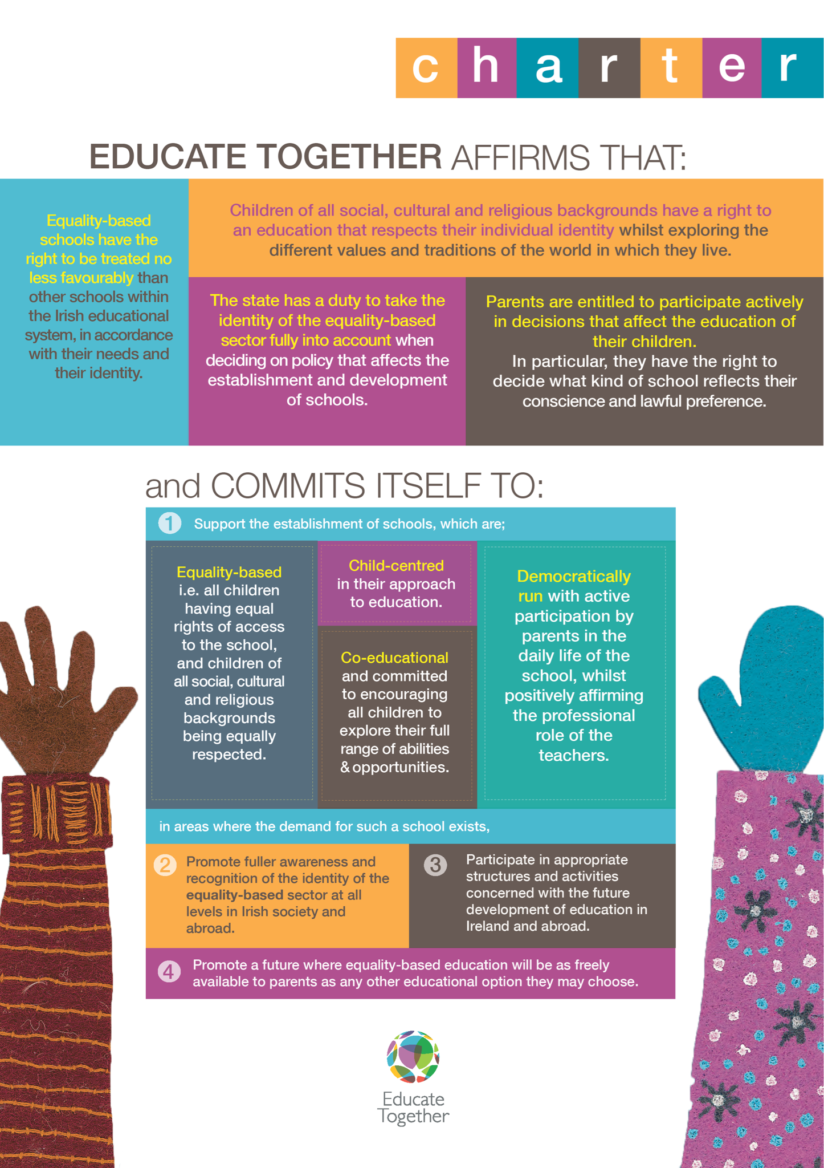

Appendix 3: Map of Catchment area:
