Maths
The children can complete the following word problems using three number addition. They will write out the sum to go with the word problem.

Example:
Anna went to the grocery store. She bought three oranges, 6 apples and 5 bananas. How many items of fruit did she buy in total? 3 + 6 + 5 = 14

- Grace made a Zoom call to 3 of her friends on Monday, 2 of her friends on Thursday and 5 of her friends on Saturday. How many friends did she speak to on Zoom that week?
- Jack had 5 marbles, Fred had 5 marbles and Joe had 4 marbles. How many marbles did they have altogether?
- Sarah and her Mammy went for a walk on Thursday and saw 4 cats, 5 dogs and 6 birds. How many animals did they see on their walk?
- Jesse was playing with his lego blocks. He used 6 yellow blocks, 6 green blocks and 7 red blocks to make his house. How many blocks did he use?
- Katie was helping her Dad cook this week. They used 3 peppers, 3 tomatoes and 2 pieces of chicken. How many ingredients did they use?
- The zookeeper was feeding the lions for three days. He used 5 pieces of meat on Monday, 3 pieces of meat on Tuesday and 8 pieces of meat on Wednesday. How many pieces of meat did he need?
- Ben watched TV for 6 minutes on Thursday, 6 minutes on Friday and 6 minutes on Saturday. How much TV did Ben watch?
- Molly was watching the cars pass by her window. 7 red cars, 6 blue cars and 5 silver cars passed by. How many cars passed by her window?
- Tom was making a smoothie. He used 4 oranges, 3 strawberries and 8 apples. How many pieces of fruit did he use?
- Lara was reading lots of books at home last week. She read 2 books on Monday, 3 books on Thursday and 6 books on Saturday. How many books did she read last week?

Tables to be learned off this week:
6 + 12 = 18
7 + 1 = 8
7 + 2 = 9

The following worksheet links can be used to accompany the above sums if you so wish or would like additional resources to complete:
https://www.twinkl.ie/resource/t-n-2546071-the-cautious-caterpillar-addition-to-10-activity-sheet

https://www.twinkl.ie/resource/t-n-5827-addition-and-subtraction-3-numbers-to-10-activity-sheet (focus on addition to 10 here rather than subtraction)

English
For the next two weeks we will be looking at the story ‘Back to Earth with a Bump’. Here is a link to the online eBook:
https://www.twinkl.ie/resource/t-l-53321-back-to-earth-with-a-bump-ebook-english
We have also included the text to the story below for those of you who may have issues using Twinkl or opening the link;

Back to Earth With a Bump
It’s evening and Hal needs to go up to bed. He brushes his teeth and he brushes his head.
The big hand’s on twelve and the small hand’s on eight. Quick, into your bedroom, it’s really quite late!
Hal closes his curtains and turns out the light, Curls under his blanket and snuggles up tight.
But just when he’s starting to snuffle and snore.... his small bed takes off from the ground with a roar!
A whoosh! and it’s out of the window they go. His house soon becomes just a dot down below.
He soars through the clouds and the dark moonlit sky and straight into space in the blink of an eye.
“It’s Earth calling Hal! Can you hear me? Come in! We’ve a mission for you – when can you begin?”
“You’re loud and you’re clear, now just tell me the plan. Please give me my mission - I’ll do what I can.”
“Please find us the Sun – it has gone from the sky. It’s vanished completely; we just don’t know why.”
“OK,” agrees Hal with a nod of his head, “I’ll track down the Sun in my space-travelling bed!”
“What’s that up ahead?” Hal squints hard as he sees a shape that is pale and all round, like a cheese!
There are craters and mountains and dust that is grey, Could this be the sun that we see in the day?
“No way!” chuckles Hal with a shake of his head, “I know what that is!” and he stands on his bed.
“There’s just no mistaking: that sphere is the Moon! I see it each night from my bed in my room!”
“We must find the Sun!” Hal commands with a jump, “Before we go straight back to Earth with a bump!
I must not give up – it’s important to try. I’ll keep up my quest for the Sun in the sky.”
“What’s that up ahead?” Hal jumps up as he spies. Some bright twinkling shapes far ahead in the sky. They sparkle and dazzle, they glow with white light. Could this be the sun that we lost in the night?
“Oh no!” giggles Hal with a wink of his eye, “I know those small diamonds high up in the sky. Those beautiful twinkling space dots are stars! I’m perfectly certain that that’s what they are!”
“We must find the Sun!” Hal commands with a jump, “Before we go straight back to Earth with a bump!
I must keep on trying, although it is hard. I’ve done well already to find all these stars!
“What’s that up ahead?” Hal stands on tiptoes. To see a vast shape that is bright red and glows.
There are mountains and valleys and deserts so dry. Could this be the sun that has gone from the sky?
“It can’t be!” says Hal as he scratches his head, “I know what that is – it’s so round and so red.
It’s perfectly clear that this planet is Mars! I’ve heard it’s the planet that’s found next to ours.”
“We must find the Sun!” Hal commands with a jump, “Before we go straight back to Earth with a bump!
This mission is hard – it’s a difficult test; But if I have tried then I’ve given my best.”
Hal looks back at Earth and then what does he see?
The planet is moving - it’s turning around! It’s slowly rotating without any sound!
Hal zooms round to find where his bedroom has gone…. and what does he find? He discovers the sun! The sun doesn’t budge but the Earth moves instead! Hal works it all out as he clings to his bed.
“When night comes we see the bright moon in the sky but in daytime the sun is the thing that we spy!”
“I knew I could do it if only I tried!” Hal smiles with delight as he looks at the sky.
“I did not give up and I did not give in and I found the Sun!” Hal shouts out with a grin.
The mystery is solved now his mission’s complete, Hal’s suddenly tired and in need of some sleep.
He soars to his country, his town, then his street and straight through the window, head first and then feet.
And back in his bedroom he snuggles down tight and drifts off to sleep for the rest of the night.
As the sun starts to rise Hal wakes up with a jump and finally comes back to Earth with a bump!

The following activities can be completed based on the above story;
- Draw your favourite part of the story
- List as many rhyming words as you can

Answer the following questions by circling the correct answer;
- What time was it when Hal went to bed?

8 o’ clock 9 o’clock 10 o’clock

- Who asked Hal to find the sun?

the Earth the moon mars

- What did Hal find that was ‘pale and all round like a cheese’?

Earth the moon mars

- What does Hal find that is ‘so round and so red’?

Mars Saturn Jupiter

- What are the bright, twinkling shapes Hal sees in the sky?

the moon the planets the stars

- What does Hal discover about the Earth at the end of the story?

It shines bright It moves It jumps up and down

- How does Hal get back through his window?

Head first and then feet Feet first and then head

- How does Hal wake up at the end of the story?

With a jump Slowly opens his eyes

The children should learn the following spellings for this week:
1. tie 2. rain 3. goat 4. weep 5. oats 6. load
7. die 8. seed 9. raid 10. quiz

The children should recite their spellings and practice writing them out individually without looking and in sentences.

Irish

This week we are looking at the topic of ‘Sa bhaile’ (At home). Here is the vocabulary for this week;

- Cistin (‘kish-tin’ = kitchen)
- Seomra codlata (‘show-m-ra cud-al-ta = bedroom)
3. Seomra folctha (‘show-m-ra ful-ca’ = bathroom)
4. Seomra suí (‘show-m-ra see’ = sitting room)
5. Gáirdín (‘on g-or-deen’= garden)
6. Halla (‘hol-a’ = hall)

The children should practice the words while looking at the pictures.

- Cistin 2. Seomra codlata
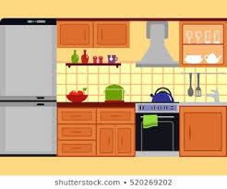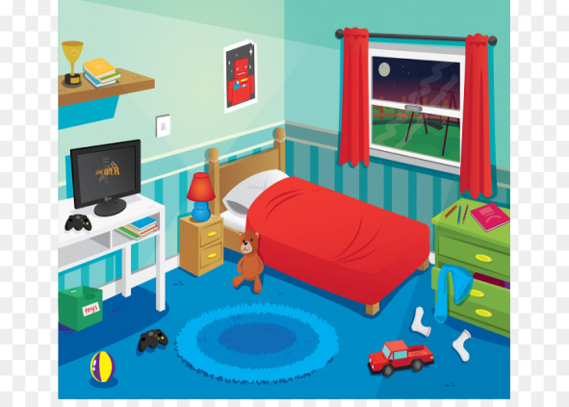

3. Seomra folctha 4. Seomra suí
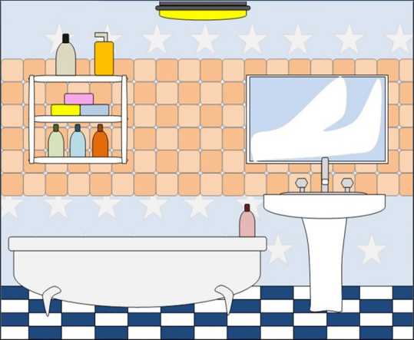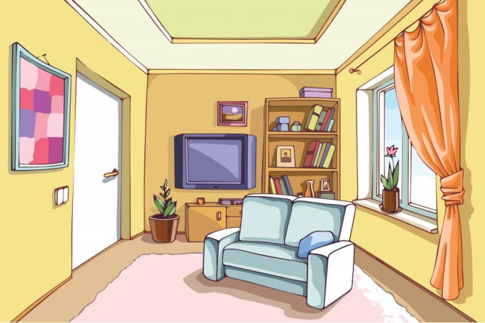

5. Gáirdín 6. Halla
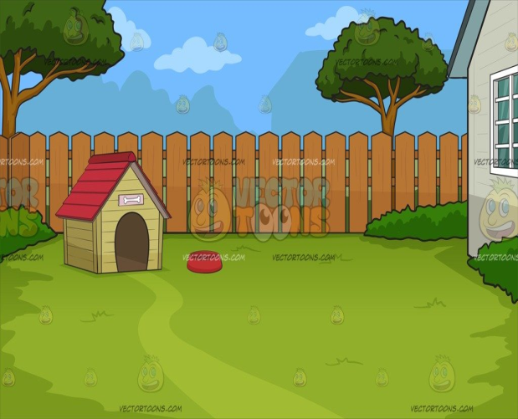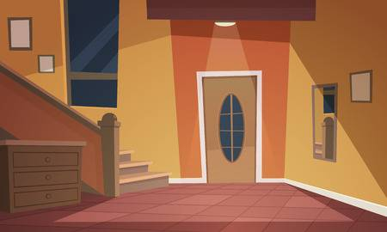

Children should complete the following worksheet.

Sa bhaile (At home)
Léigh agus tarraing pictiúir de na háíteanna/seomraí difriúla i do theach féin (read and draw pictures of the different areas/rooms in your own home).

Cistin | Seomra codlata
Seomra folctha | Seomra suí
Gáirdín | Halla

