Maths
Number : Use the symbols + and = to construct word sentences involving addition
Children must write the actual sum for the following word problems to work out the answer:
Example: Mel bumps into her toy box, 5 toys spill on the floor but 4 toys stay in the box, how many toys did Mel have in the box? 5 + 4 = 9

- A penguin at the zoo ate 3 fish during his morning feed. He also ate 4 fish during his afternoon feed. In total how many fish did the penguin eat?

- Eva jumped on the sofa 8 times and her friend Ariel jumped on the sofa 6 times. How many times in total did they jump on the sofa?

- A biscuit jar is sitting on a high shelf. Sophie stands on a pile of 5 picture books and 11 Maths books to try and reach the jar. How many books in total did she stand on?

- There are 8 pencils in the tub, 8 more pencils are added. How many pencils are there now in the tub?

- The children in Senior Infants painted a picture of a butterfly. 9 children in Jen’s class used red paint in their picture and 7 children in Clíona’s class used red paint in their picture. How many children altogether in Senior Infants used red paint?

- Jeffrey caught 6 tadpoles in a pond and that left 7 tadpoles in the pond. How many tadpoles were there before Jeffrey got there?

- The superhero rescued 8 girls and 9 boys from danger last week. How many children did he rescue altogether?

- Joe read 4 books this week and Claire read 7 books. How many books altogether did they read?

- Daisy was making cupcakes at home this week. She made 7 cupcakes on Monday and 7 cupcakes on Tuesday. How many cupcakes altogether did she make?

- Max and Dillon were playing catch. Max dropped the ball 6 times and Dillon dropped the ball 10 times. How many times did they drop the ball altogether?

The following sums can be completed to revise addition with a missing number before or after the equals sign;
- 7 + ___ = 16 8. __ + 9 = 13
- __ + 12 = 19 9. 7 + 8 =
- 7 + 11 = 10. 4 + __ = 13
- 8 + 8 =
- 9 + __ = 18
- 4 + __ = 9
- __ + 6 = 13
Tables:
Children should learn the following tables for this week;

6 + 9 = 15
6 + 10 = 16
6 + 11 = 17

English
Children should learn the following spellings for this week;
1. crab 2. chop 3. swam 4. shed 5. glad 6. shut
7. pant 8. soft 9. scrub 10. held

Children should recite their spellings and practice writing them out individually and in sentences. When using sentences make sure to remember to start your sentence using a capital letter and end it with a full stop using a finger space to separate each word.
The following short story can be read;
The Blue Kite
It was a windy day. James wanted to fly his blue kite. His Uncle Andy took him to the park. The kite flew so high. A gust of wind blew the kite into the branches of a tree. It got stuck! James was sad. The wind blew again and the kite fell to the ground. James was happy to have his kite back.
The following questions can be asked orally to your child about the story;
- What kind of day was it?
- Who wanted to fly a kite?
- Where did the kite get stuck?
- Why was James happy in the end?
Children can also draw a picture to show what happens in the story

Irish
This week we are looking at the topic of An tEarrach (Spring) and An Cháisc (Easter) Here is the vocabulary for this week;
1. uan (‘ew-in’ = lamb) 2. ciseán (‘cish-aw-in’ = basket)
3. milseáin (‘ mil-shaw-in’ = sweets) 4. sicín beag (‘shic-een- b-yug’ = chick)
5. boinéad (’bon-aid’ = bonnet) 6. ubh Chásca (‘uv-caws-ka’= Easter egg)
7. seacláid (‘shock-law-id’ = chocolate) 8. an tEarrach (‘on- tar- ok’ = Spring)
9. lus an chromchinn (‘lus-on- crum-hin’ = daffodils)
The children should practice saying the words when looking at the pictures.
1. uan 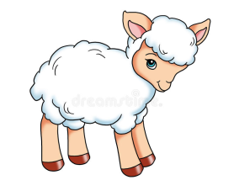 2. ciseán 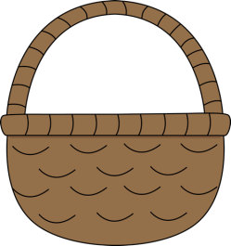

3. milseáin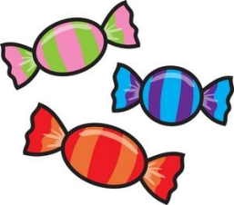 4. sicín beag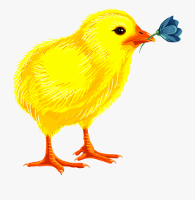

5. boinéad 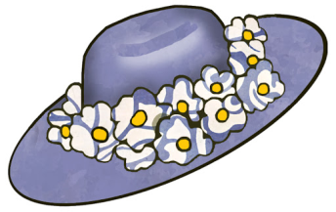6. ubh Chásca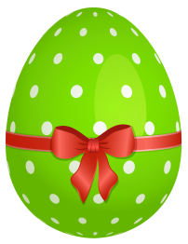

7. seacláid 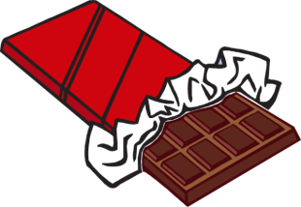 8. an tEarrach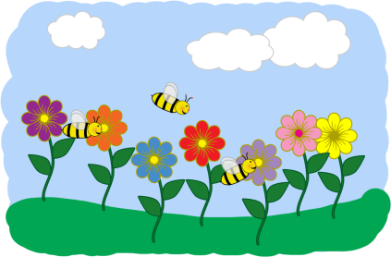

9. Lus an chromchinn 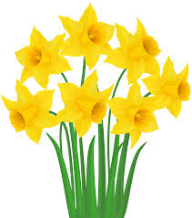

Children should complete the following worksheet
An tEarrach/ An Cháisc (Spring/Easter)
Léigh agus tarraing an pictiúr ceart i ngach bosca (Read and draw the correct picture in each box)

ubh Chásca | ciseán | milseáin
seacláid | sicín beag | uan
Lus an chromchinn | boinéad | An tEarrach

