Maths
For Maths this week we are going to continue looking at pattern and also include some work on the number line.
Children should have a copy of a number line up to 20 in front of them when completing these sums.

- 13 + 6 =
- 12 + 3 =
- 16 + 4 =
- 11 + 9 =
- 8 + 8 =
- 9 + 4 =
- 15 + 3 =
- 6 + 8 =
- 8 + 9 =
- 12 + 6 =

The children should complete the following worksheet on Twinkl and fill in the missing numbers on the number lines:
https://content.twinkl.co.uk/resource/fb/c8/T-HE-205-Filling-In-The-Missing-Numbers-On-A-Number-Line-To-20-Activity-Sheet.pdf?__token__=exp=1588862154~acl=%2Fresource%2Ffb%2Fc8%2FT-HE-205-Filling-In-The-Missing-Numbers-On-A-Number-Line-To-20-Activity-Sheet.pdf%2A~hmac=edb34b0560cce38744b888db005617df7487babb9e4964f3bd34ad730db0e808
The children should complete the worksheet below on pattern. 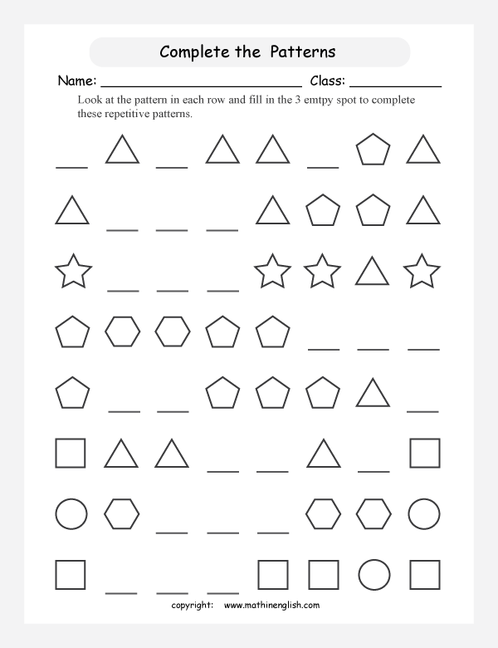

Finish the following number patterns:

- 10, 8, 6, __, ___, 0
- 5, 10, __, 20, ___, 30
- 3, 6, __, 12, __, 18, ___
- 4, 8 __, ___, ___
- 20, 18, __, __, 12, __, 8, ___, ___, 2, 0

English

This week we are going to look at the second half of the story ‘Up, Up and Away’. Here is a link to the online eBook:
https://www.twinkl.ie/resource/roi-t-2546188-exploring-my-world-up-up-and-away-ebook
If reading from the eBook link, please read from page 15 to the end this week.
We have also included the text for the second half of the story below for those of you who may have issues using Twinkl or opening the link;

Up, Up and Away
“Hand luggage on here, please,” she grinned.Kieran and Niamh backpacks into a shallow, grey tray. They watched as their belongings disappeared into a black box.
“They are just checking that there isn’t anything dangerous in them,” Mum said reassuringly. Kieran watched in amazement as the contents of his bag appeared on a little screen.
“It can see inside without even opening it!” he gasped.
The children walked forward and saw an archway in front of them. They watched as a woman walked through the doorway. A security guard appeared to wave a wand over their clothes before they were allowed to carry on.
“What are they doing?” asked Kieran anxiously. “Just checking that people are safe before they get on the plane,” Mum replied. “I’ll go first to show you.”
Kieran and Niamh waited apprehensively as Mum walked through the archway. It only took a few moments and then she waved the children on. They both stood still while the man waved the wand at their clothes before he smiled and gestured at them to carry on.
That was strange!’ thought Kieran. As they turned the corner, Kieran and Niamh were surprised to see a whole row of shops appear. There was a newsagent’s, a barber’s, lots of restaurants and even a toyshop. “Can we get a magazine for the flight?” asked Kieran. “OK,” said Mum. “Let’s go and see what they’ve got.” Kieran and Niamh chose their magazines and a packet of sweets for the journey as a treat.
“We need to head to Gate 11,” Mum announced. “That’s where our plane will be waiting for us.” They held Mum’s hands and followed the signs carefully to Gate 11. There were lots of other people sat waiting patiently on seats. An announcer explained that Gate 11 was ready for boarding and everyone began to make their way to a little desk with a door behind it. The woman at the desk checked their passports and tickets. “Have a lovely flight!” she smiled.
They walked along a corridor with little windows in it. Kieran was just tall enough to see the enormous plane waiting on the runway for them. “Welcome aboard!” a man grinned at them as they arrived at the door to the plane. Kieran helped his mum by finding their seats. “11A… 11B… and… 11C!” he said as he pointed to their row.
Mum put their backpacks into the special cupboards above their heads while Kieran and Niamh sat down and put their seatbelts on. Kieran looked out of the window. He could see one of the huge wings of the plane. “Wow!” said Niamh, bouncing in her seat with excitement as the engines began to rumble beneath them.
The plane slowly began to move along the runway. All of a sudden, the rumbling sound grew to a loud roar and the plane began to hurtle down the runway so fast that Kieran was pushed back into his seat! His heart was fluttering with excitement and his stomach did a little flip as he felt the plane lift into the sky. He couldn’t believe that he was about to embark on the adventure of a lifetime!

The following activities can be completed based on the above story;
- Draw a picture of your favourite part of the story
- Write a few sentences about your favourite holiday that you have ever been on.

* Please remember when writing sentences to keep your letters on the line (they don’t like to float!), to only use capital letters where you need to, and to always put a full stop at the end of a sentence.

The following questions can be asked orally to your child about the story and we will be asking everyone these questions at our zoom meeting on Tuesday so if you all can have some answers ready that would be great :)
- What types of shops did the children see in the airport?
- What did Mum let Kieran and Niamh get as a treat?
- If Mum forgot their passports, do you think that they would still be allowed on the aeroplane?
- Where do you think the children were flying to?
- Have you ever been on an aeroplane? If you were, how did you feel? If you were not, would you like to?
- What was your favourite part of the story?

The following spellings should be learned this week:
1. good 2. moon 3. hook 4. wood 5. food 6. roof 7. look 8. boot 9. wool 10. soon

*The children should recite their spellings and practice writing them out individually without looking and in sentences.

Irish

This week we will be engaging with the topic ‘Laethanta Saoire’ (Holidays). I know that unfortunately a lot of the children will not get the opportunity to go on holidays this year and that engaging in this topic might seem unfair to them. Nonetheless the vocabulary will be needed in future years and you can use this time to remind them of all of the fantastic holidays (in Ireland or abroad!) that they have been lucky enough to go on in previous years or to look forward to better times when this difficult time is over. Here is the vocabulary for this week.

- Laethanta saoire (‘lay-hin-ta-see-er-a’ = holidays)
- Aerfort (‘air-fort’ = airport)
- Ag eitilt (‘ig-et-il-t’ = flying)
- Thar lear (‘har-lar’ = abroad)
- An samhradh (‘on-s-ar-a’ = summer)
- An aimsir (‘on-eye-m-sh-ir’ = the weather)
- Óstán (‘oh-st-aw-in’ = hotel)
- Linn snámha (‘lin-s-naw-va’ = swimming pool)

The children should practice the words while looking at the pictures.

- Laethanta saoire 2. Aerfort

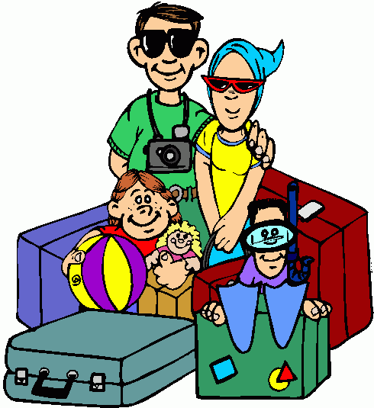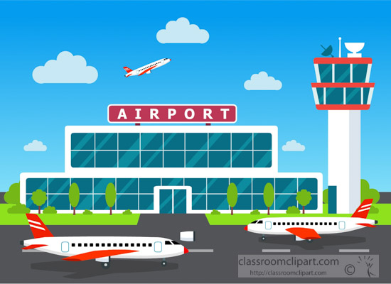

3. Ag eitilt 4. Thar lear

6. An aimsir 7. Óstán

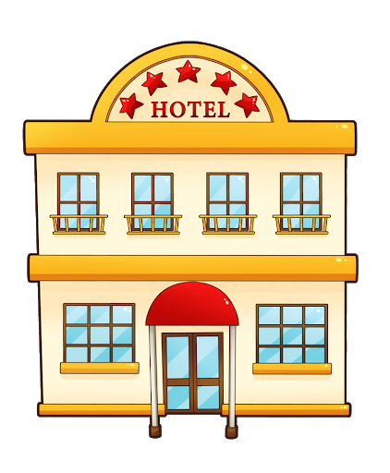

8. Linn snámha

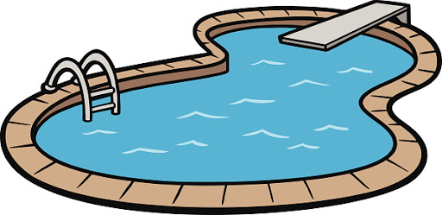

Children should complete the following work.

Tarraing pictiúr de na laethanta saoire is fearr leat riamh. Is féidir leat na habairt thíos a chuir le do phictiúr má tá baint leo le do phictiúr. Chuir an teideal ‘Na laethanta saoire is fearr liom’ ar an bpictiúr.
Draw a picture of your favourite holiday that you have ever been on. You can write the sentences below and put them with your picture if they relate to your holiday. Write the title ‘My favourite holiday’ on your picture.

Chuaigh mé go dtí an linn snámha. = I went to the swimming pool.
Bhí an aimsir go deas. = The weather was nice.
Bhí an aimsir te. = The weather was hot.
Chuaigh mé ar eitileán/bád. = I went on a plane/boat.
D’fhan mé in Éirinn. = I stayed in Ireland.
D’fhan mé in óstán. = I stayed in a hotel.
Bhí an-spraoi agam. = I had lots of fun.

