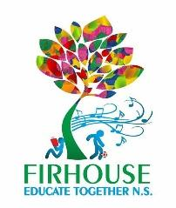

Firhouse Educate Together National School

After School/Extra Curricular Classes 2021-22

After School Classes
Monday | Tuesday | Wednesday | Thursday | Friday
Artzone  13.05 – 14.05  14.05 – 15.05 | Óle School of Language  13.05 – 14.05  14.05 – 15.05 | Lego Club  13.05 – 14.05  14.05 – 15.05 | Speech & Drama  13.05 – 14.05  14.05 – 15.05
 | Homework Club  14.05 – 15.05 | Homework Club  14.05 – 15.05 | Homework Club  14.05 – 15.05

Community Classes (Hall)
Monday | Tuesday | Wednesday | Thursday | Friday
 | Irish Dancing  17.00 – 18.00 | Ballet  15.15 – 17.45
Butterfly Yoga & Pilates  20.00 – 21.00 | Adult Choir  19.30 – 21.30 | Butterfly Yoga & Pilates  19.15 – 20.15  20.30 – 21.30

