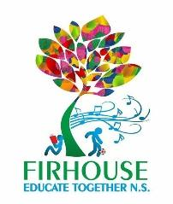

Firhouse Educate Together National School

After School/Extra Curricular Classes 2019-20

After School Classes
Monday | Tuesday | Wednesday | Thursday | Friday
Artzone  13.05 – 14.05  14.05 – 15.05 | Jill O Neill School of Dance  13.05 – 14.05  14.05 – 15.05 | Kids Fun Yoga  13.05 - 14.05 | Speech & Drama  13.05 – 14.05  14.05 – 15.05 | Kids Fun Yoga  14.05 - 15.05
Lego Club  13.05 – 14.05  14.05 – 15.05 | Olé School of Language  13.05 – 14.05  14.05 – 15.05
 | Homework Club  14.05 – 15.05 | Homework Club  14.05 – 15.05 | Homework Club  14.05 – 15.05

Community Classes
Monday | Tuesday | Wednesday | Thursday | Friday | Saturday
 | Irish Dancing  17.00 – 18.00 | Ballet  15.15 – 17.45 |  |  | Arabic School  10.00 – 15.00
 |  | Butterfly Yoga & Pilates  19.15 – 20.15  20.30 – 21.30 |  |  | Move It  08.00 - 09.00
Olé School of Language

15.15 – 16.15
Ballroom Dancing  18:30 - 20:30 | Adult Choir  19.30 – 21.30 Every second week starting 21/1/20 |  | Ballroom Dancing  18:00 - 21:00

