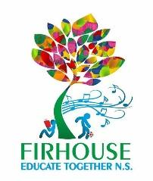
Firhouse Educate Together National School,
Ballycullen Drive, Firhouse, Dublin 24
Tel: 01 4061010 Email: firhouseetns@gmail.com www.firhouseetns.ie

Booklist/Resources for Junior Infants 2022/23

Dear Parents and Guardians,

The following are supplied by the school and we will send you an

online payment request shortly for €115 to cover same, payable by 30th August 2022

Below is the list of costs for these items:

Sight and Sounds Book (4schools.ie) €2.00

Copies for the year, folder and document wallet, stationery €15.00

Pupil Personal 24-hour Insurance €8.00

Book Rental Scheme:
(Includes selection of graded readers, supplementary readers,
parallel readers - large / small format books) €20.00

Photocopying/Online Resources €22.00

Arts & Sports Materials, Triangular Pencils, Pencil Sharpener,
Ruler, Erasers, Pritt Stick Glue, Crayons €33.00

Membership of Educate Together €15.00

Total Cost €115.00

Art: Please provide an old large t-shirt to wear over clothing for art, which will be kept in school - Please make sure to put your child’s name on it and on all clothing they bring into school.

